IMPLEMENTATION OF DIFFIE HELLMAN KEY EXCHANGE ALGORITHM
Aim
To implement the Diffie–Hellman Key Exchange Algorithm using C programming and verify that both communicating parties generate the same shared secret key.

Algorithm
- Start the program.
- Choose two public numbers:
  - A prime number (P)
  - A primitive root (G)
- Enter the private key of User A (a).
- Enter the private key of User B (b).
- Compute User A's public key:
  - A = Gᵃ mod P
- Compute User B's public key:
  - B = Gᵇ mod P
- Generate the shared secret key:
  - User A computes: K₁ = Bᵃ mod P
  - User B computes: K₂ = Aᵇ mod P
- Compare both shared keys.
- If K₁ = K₂, the key exchange is successful.
- Display the public keys and the shared secret key.
- Stop the program.

Program:
#include <stdio.h>

// Function to calculate (base^exp) % mod
long long power(long long base, long long exp, long long mod)
{
long long result = 1;
while (exp > 0)
{
result = (result * base) % mod;
exp--;
}
return result;
}

int main()
{
long long P, G;
long long a, b;
long long A, B;
long long keyA, keyB;

printf("Enter Prime Number (P): ");
scanf("%lld", &P);

printf("Enter Primitive Root (G): ");
scanf("%lld", &G);

printf("Enter Private Key of User A: ");
scanf("%lld", &a);

printf("Enter Private Key of User B: ");
scanf("%lld", &b);

// Public Keys
A = power(G, a, P);
B = power(G, b, P);

printf("\nPublic Key of User A = %lld", A);
printf("\nPublic Key of User B = %lld", B);

// Shared Secret Keys
keyA = power(B, a, P);
keyB = power(A, b, P);

printf("\n\nShared Secret Key generated by User A = %lld", keyA);
printf("\nShared Secret Key generated by User B = %lld", keyB);

if (keyA == keyB)
printf("\n\nKey Exchange Successful.");
else
printf("\n\nKey Exchange Failed.");

return 0;
}

Output:
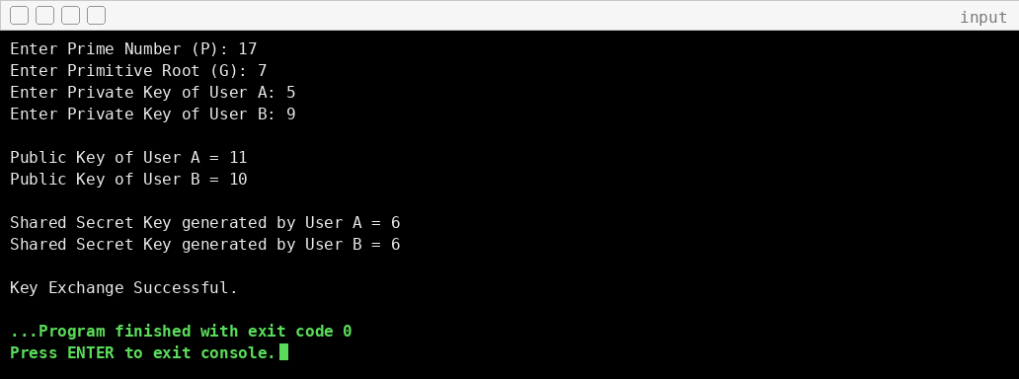
Result:
Thus, the Diffie–Hellman Key Exchange Algorithm was successfully implemented using C, and both users generated the same shared secret key, proving that secure key exchange was achieved.

